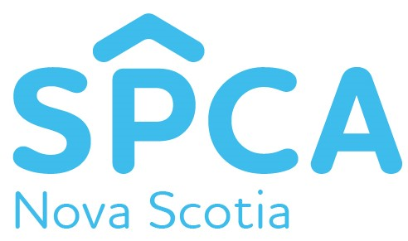
Nova Scotia SPCA Provincial Office
P O Box 38072 STN Burnside
Dartmouth, Nova Scotia
B3B 1X2
Date: March 6, 2020
For Immediate Release
Dartmouth Man and Woman Charged for Animal Cruelty
Dartmouth, Nova Scotia – Mark Davis, 43, and Allison Black, 36, of Dartmouth, have been charged with being a custodian of an animal and permitting the animal to be in distress, contrary to Section 26 (2) of the Animal Protection Act of Nova Scotia.
On January 4, 2020, the Nova Scotia SPCA received a complaint regarding concern for a dog’s wellbeing. Through the course of the investigation, it was determined that the dog was neglected for a period of time causing it to be in distress. As a result of the evidence collected, charged were laid on February 28th, 2020.
“Neglect, whether it is deliberate or unintentional, can lead to compromised health of the animal causing unnecessary suffering,” says Jo-Anne Landsburg, Chief Provincial Inspector at the Nova Scotia SPCA. “As a pet owner, you must be willing to provide treatment when your pet needs medical attention. If you cannot provide appropriate care, it is your responsibility to reach out for help.”
Davis and Black are scheduled to appear at Dartmouth Provincial Court at 9:30am on April 27, 2020. The Nova Scotia SPCA has a zero-tolerance policy for animal cruelty. They urge you to report acts of animal cruelty by contacting the confidential toll-free line at 1-888-703-7722.
-30-
About the Nova Scotia SPCA
Proudly following no-kill principles, the Nova Scotia SPCA is a registered charity that helps companion animals in need. Every year, more than 16,000 pets are helped through animal rescue, progressive programs, and rehoming opportunities. They do not receive any government funding for their shelters, so the SPCA relies on community support to help care for local pets in need. To learn more visit www.novascotiaspca.ca

Media Contact:
Taylor Mundy
Communications & Development Coordinator
902-835-4798 ext 224
tmundy@spcans.ca

